Hands-On 4 – Difference between JPA, Hibernate, and Spring Data JPA
🔸 JPA
- Java specification (JSR 338) for persistence in Java applications.
- Provides interfaces like EntityManager, @Entity, etc.
- No implementation of its own.
🔸 Hibernate
- A widely-used ORM framework.
- Implements JPA.
- Manually handles Session, Transaction.
- More boilerplate code.
Code:
Session session = factory.openSession();
Transaction tx = session.beginTransaction();
session.save(employee);
tx.commit();
Output : 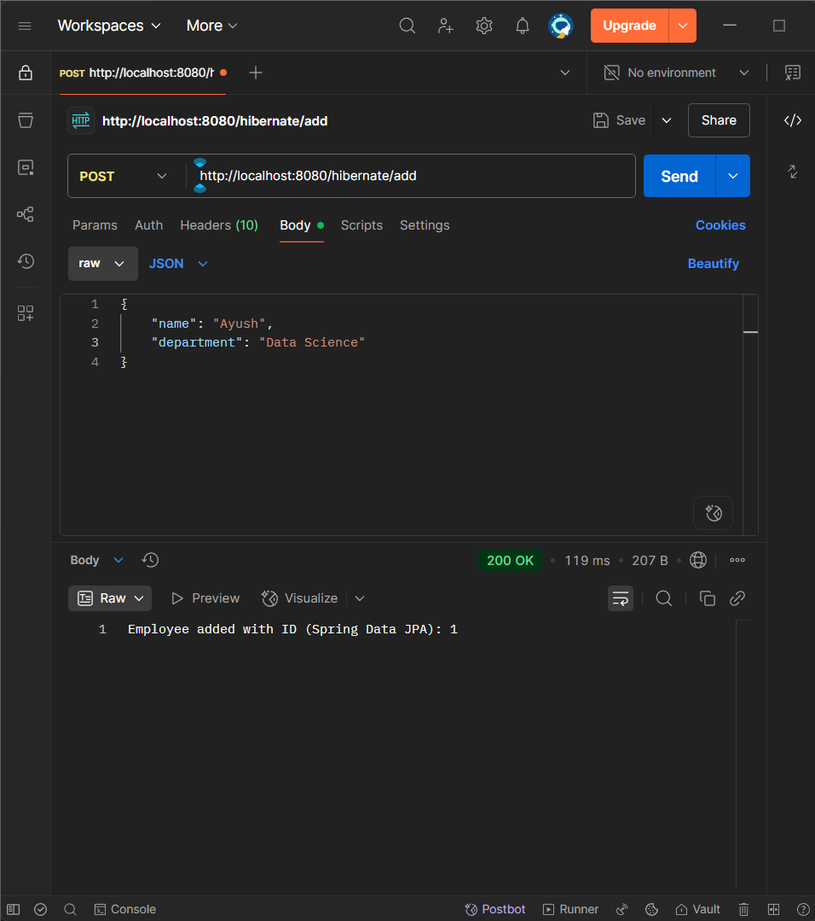
🔸 Spring Data JPA
- Built on top of JPA and Hibernate.
- Eliminates boilerplate DAO code.
- Uses JpaRepository and method naming conventions.
- Handles transaction and session automatically.
Code:
@Autowired
EmployeeRepository repo;
repo.save(employee);
Output : 